Sample One-Page Abstract for the 43rd ARA Congress, 18 point Times New Roman, bold, 8 pt before, 6 pt after, one line space title, centered
First Author¹, Second Author^{2*}, POPESCU Ion, Times New Roman 12 pt, centered
¹ XY University, City, Address, Postal Code, Country.
² XY company, City, Address, Postal Code, Country.
*e-mail address of corresponding author

This document is an example of one-page abstract for the Book of Abstracts. The full conference papers will be published in the ARA Journals. However, for the conference attendant’s convenience and publicity, a Book of abstracts will be available on the conference web site.
The goal of the book of abstracts is to provide the audience with some more information about the papers being presented, so they can choose which presentations to attend during parallel sessions. To this end, you can of course re-use the abstract provided when submitting the paper. Please, consider that this page of abstract acts as advertising for your presentation. Therefore, you can try to make it more attractive and informative. For this purpose, you can also include figures, such as Figure 1, and a few optional references, such as [1] or [2], acknowledgement, etc. Keywords are mandatory.
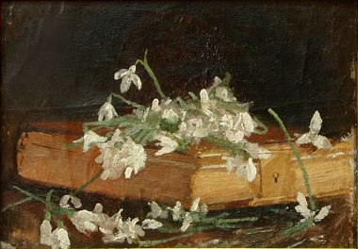
Figure 1. Example of a figure caption. Use 9 point Times New Roman.
The maximum one-page abstract should be written in English and prepared, MS Word.doc, size 7.44”x9.69” or 189x246 mm using the Times New Roman font, 18 pt for the title, 12 pt for the authors’ names and affiliations (presenter’s name in Bold), and 10 pt for the text, single spaced. The left and right margins should be 2 cm, the top and the bottom margin should be 2 cm. Please do not exceed these limits, or your MS Word file will not be accepted. Please also note that this abstract must be submitted to the conference organizers in due time, and that at least one author should have registered by that time, for the final paper to be included in the conference program.
Acknowledgement (if necessary)
Keywords: maximal 8, the first keyword should be the Congress topic (e.g. Anthropology, Art & Music, Biology, Chemistry, Computer Science, Economy, Engineering, Environment, History, Interdisciplinary Sciences, Law, Linguistics & Literature, Mathematics, Medicine, Politics & Philosophy, Physics, Social Sciences, Theology)
References
- Watson, J.D, Crick F.H.C, A structure for the Deoxyribose Nucleic Acid, Nature 171, 737-738, 1953.
- Mattson, S.E., Elmqvist, H., Otter, M.: Physical system modeling with Modelica, Control Engineering Practice, v. 6, pp. 501-510, 1998

